**Chapter 12: Circular Motion**

***Please remember to photocopy 4 pages onto one sheet by going A3→A4 and using back to back on the photocopier.***

We know that angles can be measured in degrees. They can also be measured in something called Radians*, where

$$θ= \frac{s}{r}$$

**Angle (in radians) = $\frac{Arc Length}{Radius}$**

**Angular Velocity**

$$= \frac{}{t}$$

**Angular Velocity is the rate of change of angle with respect to time.**

Angular Velocity is measured in radians per second, (rad/s).

The symbol for angular velocity is ω (pronounced “omega”).

**If an object is moving in a circle at constant speed, it is accelerating**.

This isbecause while its speed is not changing, its velocity is. Why? Because velocity is defined as speed in a given direction, so if direction is changing, even though speed is not, then the velocity is changing, therefore the object is accelerating.

$$v= r$$

**Relationship between Linear Speed (*v*) and Angular Velocity (*ω*)**

**To derive *v = rω***

⇒

{divided both sides by *t*}

$\frac{θ}{t}=\frac{s}{t}×\frac{1}{r}$ but $\frac{θ}{t}$ = ω and $\frac{s}{t}$ = *v*

ω =  *v = rω*

**Centripetal Force\***

The force - acting in towards the centre - required to keep an object moving in a circle is called a centripetal force.

**Centripetal Acceleration**

If a body is moving in a circle the acceleration it has towards the centre is called Centripetal Acceleration.

*For both of the definitions above you must refer the object moving in a circle and that the direction is in towards the centre.*

**Formulae for Centripetal Acceleration and Centripetal Force**

a = rω2

but because v = rω we also have

F = mrω2



And because *F = ma* we get and also

These formulae are all on page 51 of the log tables, and you should have this page open in front of you when doing these questions in order to familiarise yourself with them.

**Circular Satellite Orbits**



**Relationship between Periodic Time and Radius for a Satellite in Orbit\***

**Derivation of formula:**

We compare two formulae which we have for Force:

The first is the *Universal Gravitational* *Force* formula: 

The second is the *Centripetal Force* formula: 

Equate both forces (because both equations apply to satellite motion),

Centripetal force = gravitational force

$$\frac{mv^{2}}{r}=\frac{Gm_{1}m_{2}}{d^{2}}$$

Cancel one ‘m’ from both sides

Replace the d2 in the first formula with r2 (because in this scenario the distance between the satellite and the planet also corresponds to the radius of the circle that the satellite is tracing out.  
Cancel one ‘r’ both sides

 v2

You now have

*Equation (1)*

{**You must be familiar with using this equation as it comes up a lot and is not in the log tables**}

Now *v* = speed = distance/time.

Distance in this case is the circumference of a circle (2πR for circular satellite orbits)

⇒  ⇒  *Equation (2)*

Equating Equations (1) and (2) we get 

Note that there are a total of three formulae here; all three are either on the gravity page or on the circular motion page of the log tables.

Why so many f@#%ing formulae?*

**Geostationary Satellites**

These are satellites which remain (are stationery) over one position of the globe, and their orbit is called a Geostationary orbit.

We know that if we want a satellite to remain over a specific spot on the Earth’s surface it must have the same periodic time as the Earth (24 hours). The formula above allows us to calculate the height which the satellite must be at (approx 36,000 km above the equator) in order to have a periodic time of 24 hours).

**Question(s) to make you think**

Use one of the formulae above to calculate your current speed as you sit on your ass on a planet that is rotating on its axis once every 24 hours.

**Leaving Cert Physics Syllabus: all higher level**

|  |  |  |  |
| --- | --- | --- | --- |
| **Content** | **Depth of Treatment** | **Activities** | **STS** |
|  |  |  |  |
| Circular Motion | Centripetal force required to maintain uniform motion in a circle.  Definition of angular velocity ω.  Derivation of *v = rω*.  Use of *a = rω2*, *F = mrω2* | Demonstration of circular motion.  Appropriate calculations. |  |
|  |  |  |  |
| Gravity | Circular satellite orbits – derivation of the relationship between the period, the mass of the central body and the radius of the orbit. | Appropriate calculations. | Satellites and communications |

**Extra Credit**

**\*Angles can also be measured in something called Radians**

So why do we use radians? Well we’re used to dividing a circle up into 3600, but that’s completely arbitrary; it could be 1000, 2000 or just about anything else you want it to be.

It seems to go all the way back to the Mesopotamians over 6,000 years ago, who liked to work with the number 60, partly probably because it could be divided up so many different ways, i.e. 1, 2, 3, 4, 5, 6, 9, 12, 24 and 30. This got picked up by the Babylonians and passed on to the Egyptians. And from there to us. The circle has 6 × 60, or 360 parts. It’s popularity may also be related to fact that it is close to the number of days in the year.

Radians however are not arbitrary. If θ is defined as arc length divided by radius, and we apply this to the number of radians in a full circle, we get arc length (which in this case is circumference of a circle - 2πr) divided by the radius r.

This gives us 2π radians. i.e. 360(degrees) = 2π (radians).

You may have noticed on your calculator that the grad is another unit. Apparently some engineers use this unit. There are 400 grads in a circle. It has some advantages, but the sooner our school calculators lose this unit the better.

**Conservation of angular momentum –** not on the syllabus, but interesting nevertheless.

You have noticed that when a figure dancer on the ice rink pulls in her arms, her body spins more quickly.

This is because angular momentum involves the product of radius and angular velocity; if the radius decreases the angular velocity must increase in order for the angular momentum to remain constant.

This can also be demonstrated by sitting on a rotatable seat and having someone spin you around while your arms are outstretched.

Now bring in your arms – you speed up!

The effect is more noticeable if you hold a heavy weight (a barbell or a book) in each hand. But be careful!

Did you know that the engine in an airliner is only loosely connected to the frame?

If the blades were to stop suddenly the plane would react violently (the change in angular momentum of the blades has to be equalled by a change in momentum of some other part of the plane).

It’s better if the engine takes the brunt of it, but doesn’t pass the vibration on to the rest of the plane.

To enable this there is a deliberate weak link that causes the engine to literally fall out of the plane.

There was also a space-rocket which was travelling through the solar system, but which kept veering off course. Eventually the scientist realised that that playing the tape-deck at high speed inside the spacecraft caused the ship itself to rotate in the opposite direction and veer off course!

The most amazing example of this is *neutron stars.*

These are stars which are three or four times the mass of our sun, but only a fraction of the size. Because their radii have decreased so much, their spin-rate must increase accordingly –some stars carry out a full revolution in a thousandth of a second!

This led to discovery of *pulsars* by the Irish astronomer Jocelyn Burnell, who initially thought the regular pattern of electromagnetic signals being emitted from these rapidly rotating “pulsing stars” (pulsars) might be due to an alien life-form (she didn’t take the possibility *too* seriously).

She did however call the first pulsars *LGM1* and *LGM2* (*LGM* standing for ‘Little Green Men’).  
It’s considered by many to have been a travesty that she never received a Nobel Prize for her discovery. Strangely enough, her supervisor did receive a Nobel Prize for the same achievement.

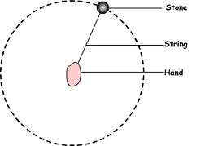**Centripetal Motion**

‘centripetal’ means ‘centre seeking’.

One of the greatest misconceptions in all of science is to with circular motion, and that’s one reason why many students don’t like this chapter.

Look at the image of the stone moving in a circular path above a person’s head.

If an object is to go round in a circle it must have a force pulling it inwards towards the centre of the circle e.g. the pull of a string on an object being swirled round. Without a force towards the centre of the circle, the object will carry on in a straight line!

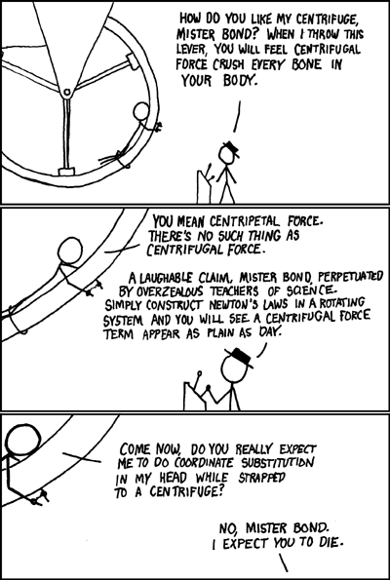The force towards the centre is called the centripetal force but – and here’s the important bit – what causes this centripetal force will change from situation to situation.

The misconception that arises here is that students (teachers?) think that the centripetal force is a type of force – it’s not; it’s just a name given to any force that causes an object to move in a circle.

So for the moon orbiting the Earth, the centripetal force is gravity.

For a stone tied to a string swinging above your head the centripetal force is the tension in the string.

For a bike going around a bend the centripetal force is friction

Sometimes reference is made to a centrifugal force – a force acting outwards on an object travelling in a circle. There is no such force. The cyclist on the wall of death does not experience an outward force towards the wall. Instead the wall exerts an inward force on the cyclist, towards the centre of the curved wall, which results in circular motion. When going around a corner a car, passengers experience an inward force being exerted by the side of the car to prevent them continuing on in a straight line.

So for the diagram above many (most?) students would put in three forces; gravity (acting downwards), tension (acting in towards the centre) and a centrifugal force acting outwards. Hopefully by now you will see that the centrifugal force does not exist.

Xkcd.com/123

**\*Relationship between Periodic Time and Radius for a Satellite in Orbit**

**Congratulations**  
You have just arrived at an equation which bookmarks a seminal moment in the history of science.

Around this time (late16th century) an astronomer called Johannes Kepler discovered empirically (i.e. by analyzing data on the motion of planets) that the square of the periodic time of these planets (time for one complete orbit around the sun) is proportional to the cube of their distance from the sun.  
Kepler actually stole the necessary data from a colleague, Tycho Brahe, but that’s nothing new in the world of Science. We will conveniently ignore that for now.

Later on Newton came along and was able to demonstrate this relationship mathematically, by combining a well-known equation for circular motion on Earth  with his own universal law of gravitation. 

We are about to follow in his footsteps and see exactly what he did and how he did it. Do not under-estimate the importance of this exercise (yes you have to know it for exam purposes, but that’s not why I consider it important).

This event had two very important consequences.

1. It showed that Newton’s Law of Gravitation must be valid in its own right, which was very important in securing Newton’s reputation as a giant of science, both at the time and for posterity.
2. Even more importantly, it demonstrated that ‘the heavens’ followed the same rules of science as those which operated here on Earth.  
   This meant that they were a legitimate area of study, and so Astronomy (which in turn led to Cosmology) was given an added respectability. Just to give a sense of what people believed at the time, Kepler had to spend much of his time during this period defending his mother of charges of being a witch.

I can think of no modern discovery which compares with this. Even if we discovered life on Mars it really wouldn’t be that big a deal. For up to this point the heavens were considered off-limits – the realm of God or the gods or whatever you’re into yourself. But now they could be shown to be just another series of objects which followed set rules, much like cogs in a complicated clock. So God was being pushed into the wings. You could see why neither Martin Luther or the Vatican Church would have been keen fans.

Kepler was following on the work of Nicolas Copernicus (known to science students down the ages as ‘copper knickers’), who in turned showed that the Earth revolved around the Sun, not the other way around.  
Galileo’s run in with the Church was because he supported Copernicus’ view, so Galileo never actually made that discovery, but he was happy to use it to make fun of the church authority figures of the time. And we all know how that worked out for him.

So this was really the dawn of science, and progress was hindered by medieval views of the astronomers themselves. It took Kepler decades to realise that the orbit of the planets was elliptical in nature, not circular. He had assumed initially that the motion *had to be circular* because a circle was *a perfect shape* (harping back to the teachings  of Pythagoras and Aristotle, among others) and therefore would have been more pleasing to God who obviously had created the planets in the first place.

Similarly Newton, despite being heralded as one of our greatest ever scientists, spend up to 90% of his time trying to date the creation of Earth by tracing who gave birth to who in the bible.

But then Newton had another problem. He realised that Kepler was correct in stating that the planets traced out *elliptical* orbits, but even Newton’s equations didn’t fully match the path of the heavenly bodies; according to Newton’s equations the planets should slowly but exonerably drift from their current pathways. He couldn’t figure out why this didn’t happen – after all, his equations seemed to be perfect in every other way. And Newton believed that he was getting his ideas directly from God. Which doesn’t leave much room for admitting you made a mistake.

We now know that while Newton’s equation are very accurate, we actually need Einstein’s Theory of General Relativity to explain why they don’t *precisely* describe the motion of the planets.

It’s interesting to note that Newton’s explanation was that God must step in every so often to gently *nudge* the planets back into their preferred orbits. Now as you now know, invoking a deity to explain discrepancies in scientific observations is the antithesis of Science. So perhaps Newton wasn’t actually so mighty after all. This is partly why he is sometimes referred to as the last sorcerer rather than the first scientist.

So now we’re up to Einstein. His general theory of relativity suggested that the universe was expanding, but just like all of his predecessors he was a man of his time, and this coloured how he saw the world. It was believed at the time that the universe has always been the way it is now (this is referred to as the ‘Steady State’ theory). Einstein figured that there must be some mistake in his paper so he introduced what he called a ‘cosmological constant’ which basically amounted to a fudge factor which altered the implications of his calculations and prevented the universe from expanding.

Which was all very well until Hubble (he of the ‘Hubble’ telescope) showed that the universe was actually expanding after all.

Doh!

Einstein referred to this as his greatest ever blunder.

So there you have it. This has been my attempt to put some context on the derivation that we are about to carry out. It is our chance to repeat one of the greatest moments in the history of science.

So you have two options; you can consider this exercise to be a pain in the ass or you consider it an incredible privilege to be in a position where you can follow in the footsteps of giants.

I think we know which option I go with.

And don’t be afraid to tell your parents this tonight; they may well throw their eyes up to heaven but if they do that’s a slight on them – not on you.

**\* Why so many f@#%ing formulae?**

Don’t know; I’m just glad it’s you and not me who has to know them.

For what it’s worth, none actually need to be learned off by heart;

**ω = θ/t** comes directly from the definition of angular velocity and **θ = s/r** comes directly from the definition of a radian.

**v = rω** is obtained by dividing the previous equation by t on both sides (and this derivation needs to be known anyway).

The **two** **formulae for acceleration** are in the log tables; page 40 and the two formulae for force are obtained by simply multiplying the relevant acceleration by m.

The amount of formulae that need to be learned in Physics can be rather intimidating, so any help you can get to alleviate your suffering should be availed of. This chapter contains more formulae than most others, and possibly as a result of this students often try to avoid questions on circular motion when they can.

I suggest you get a sheet of A4 paper and put all these equations on it, showing how they are interconnected.

Taking a ‘big picture’ approach like this should help to reduce the intimidation factor.

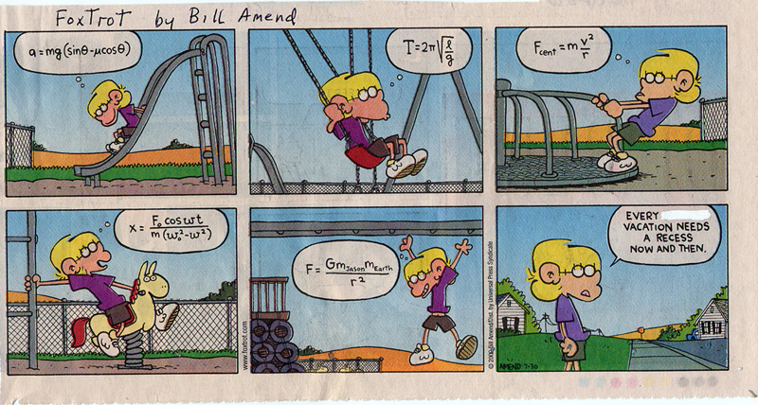

**Exam Questions**

G = 6.7 × 10-11 N m2 kg-2, Radius of Earth = 6.4 × 106 m,

Mass of Earth = 6 × 1024 kg. Mass of the sun = 2 × 1030 kg. Mass of Saturn = 5.7 × 1026 kg.  
Mean distance of Saturn from the Sun = 7.8 × 1011 m.

1. [2006][ 2005]

Define angular velocity.

1. [2006]

Derive the relationship between the velocity of a particle travelling in uniform circular motion and its angular velocity.

1. [2002]

A particle travels at a constant speed of 10 m s-1 in a circle of radius 2 m. What is its angular velocity?

1. [2006]
2. A student swings a ball in a circle of radius 70 cm in the vertical plane as shown. The angular velocity of the ball is 10 rad s–1. What is the velocity of the ball?
3. How long does the ball take to complete one revolution?
4. [2005]

Define centripetal force.

1. [2004]

Give an expression for centripetal force.

1. [2004]
2. Centripetal force is required to keep the earth moving around the sun.

What provides this centripetal force?

1. In what direction does this centripetal force act?
2. [2009]

A skateboarder of mass 70 kg has a speed of 10.5 m s–1 as he enters a circular ramp of radius 10 m.

What is the centripetal force acting on him?

1. [2004]

The earth has a speed of 3.0 × 104 m s–1 as it orbits the sun.

The distance between the earth and the sun is 1.5 × 1011 m. Calculate the mass of the sun.

1. [2009]

The moon orbits the earth. What is the relationship between the period of the moon and the radius of its orbit?

1. [2008][2005]

Derive the relationship between the period of the ISS, the radius of its orbit and the mass of the earth.

1. [2005]
2. A satellite is in a circular orbit around the planet Saturn.

The period of the satellite is 380 hours. Calculate the radius of the satellite’s orbit around Saturn.

1. [2008]

The international space station (ISS) moves in a circular orbit around the equator at a height of 400 km.

1. Calculate the period of an orbit of the ISS.
2. After an orbit, the ISS will be above a different point on the earth’s surface. Explain why.

**Exam Solutions**

1. Angular velocity is the rate of change of angle with respect to time.
2. θ = s /r

⇒ θ /t = s/rt

⇒ ω = v /r

⇒ v = ω r

1. v = rω  ω = v/r = 10/2  ω = 5 rad s-1
2. v = ω r = (10)(0.70) = 7.0 m s-1
3. T= 2πr/v = 2π(0.70)/v = 0.63 s
4. The force - acting in towards the centre - required to keep an object moving in a circle is called Centripetal Force.



1. Gravitational pull of the sun.
2. Towards the centre.
3. ** =** 70 (10.5)2/10 = 771.75 N
4. and  Equating gives v2  Ms = v2R/G

⇒ Ms = (3.0 × 104)2 (1.5 × 1011)/6.7 × 10–11 = 2.0 × 1030 kg.

**Note**

**Strictly speaking the distance (or radius) is from centre to centre.** In this case the question doesn’t specify whether the quoted distance is from surface to surface or from centre to centre, but it doesn’t really matter because the diameters of both spheres are insignificant relative to the overall distance. For an artificial satellite in orbit around a planet however the diameter of the planet would have to be taken into account.

1. The period squared is proportional to the radius cubed.
2. See notes Circular Motion chapter for a more detailed derivation.



⇒

⇒ 

1. T = 380 × 60 × 60 = 1.37 × 106 s

r3 = T2GM/4π2  r3 = (1.37 × 106)2(6.7 × 10–11)( 5.7 × 1026)/ 4π2  r = 1.2 × 109 m

1. R = (400 × 103 + 6.4 x 106 ) = 6.8 × 106 m



⇒ T2 = 3.1347 × 107  T = 5.6 × 103 s

1. The ISS has a different period to that of the earth’s rotation (it is not in geostationary orbit).